ELEMENTARY
Grammar Practice 2

A. Fill in the blanks with the correct words from the brackets.
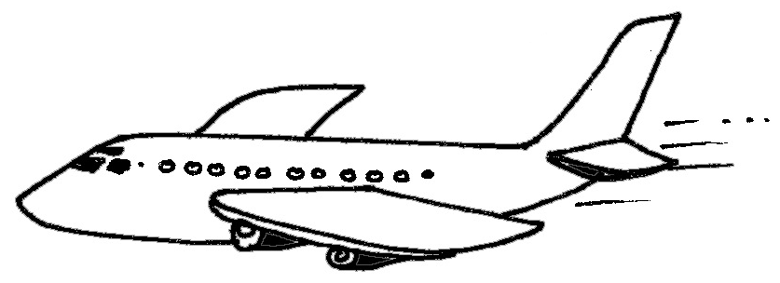
1. He ____________ across the lake to save a child. (swim / swam)
2. She ____________ a letter to her mother. (write / wrote)
3. Children love to ____________ in the park. (play / played)
4. Vicky ____________ an aeroplane in the sky. (see / saw)
5. The bird ____________ sweetly. (sing / sang)
B. Pick six doing words from the wordsearch and write them on the blanks.
s | i | t | o | u | r | p | l | a | y
l | r | o | z | r | e | a | d | q | m
e | e | i | u | e | x | g | r | u | n
e | g | y | u | o | p | x | v | g | t
p | e | b | w | r | i | t | e | j | k

1. _______________
2. _______________
3. _______________
4. _______________
5. _______________
6. _______________

