ELEMENTARY
Reading Practice 1

Read the following sentences.
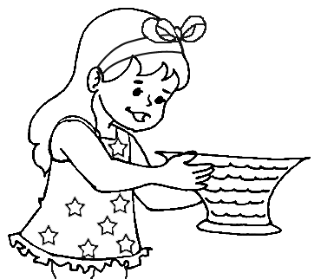
Look at this girl. She is in a pink dress. Her shoes are red. She has a blue ribbon in her hair. She is holding a big basket of flowers in her hands. Now complete this picture and colour.
Give this girl a name.
Write it here. _________________

