ELEMENTARY
Vocabulary Practice 1
A. Write five names in each of these columns.

B. Look at this school. Write as many words as you can think about it on the lines given. Two words are given.
People | Animals | Things | Vehicles
Sister | Monkey | Glass | Car
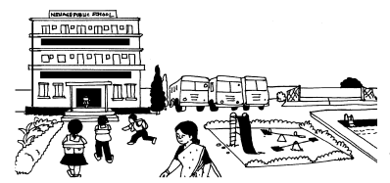

children,buses___________________________________________________________________________________________________________________________________________________________________________

