ELEMENTARY
Vocabulary Practice 2

A. Read and draw.
a rabbit eating a carrot
a parrot on the wall
a ribbon in a bell

B. Match words with their meanings.
pretty used for carrying a baby
pram playful act
pride another word for beautiful
prank you feel it when you do well
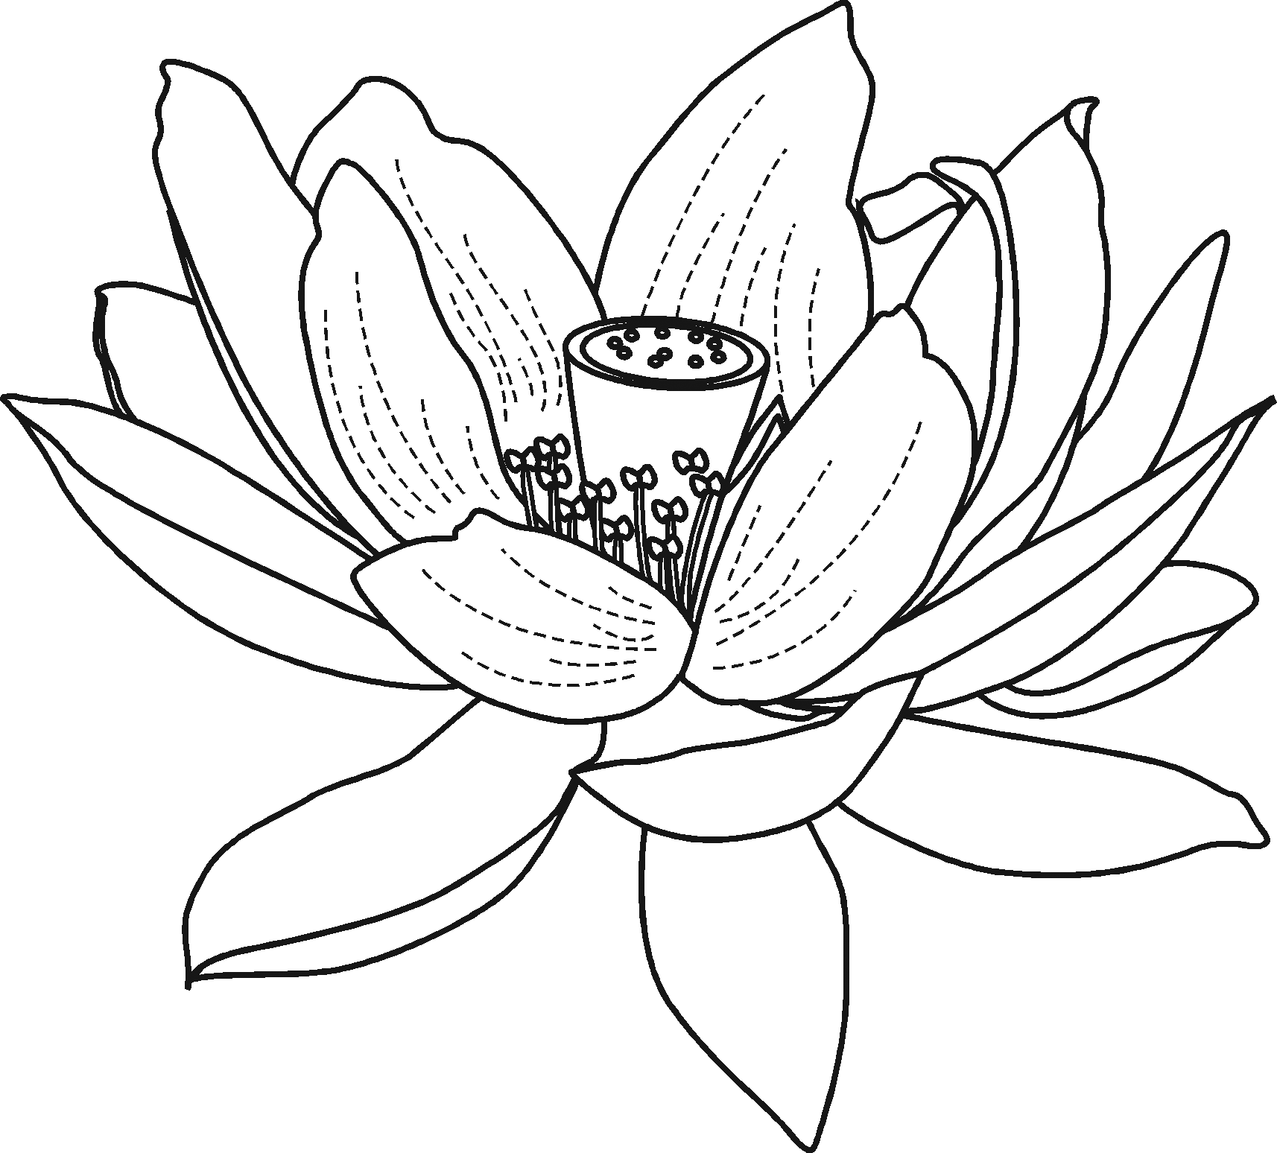
C. Complete the names of these flowers.
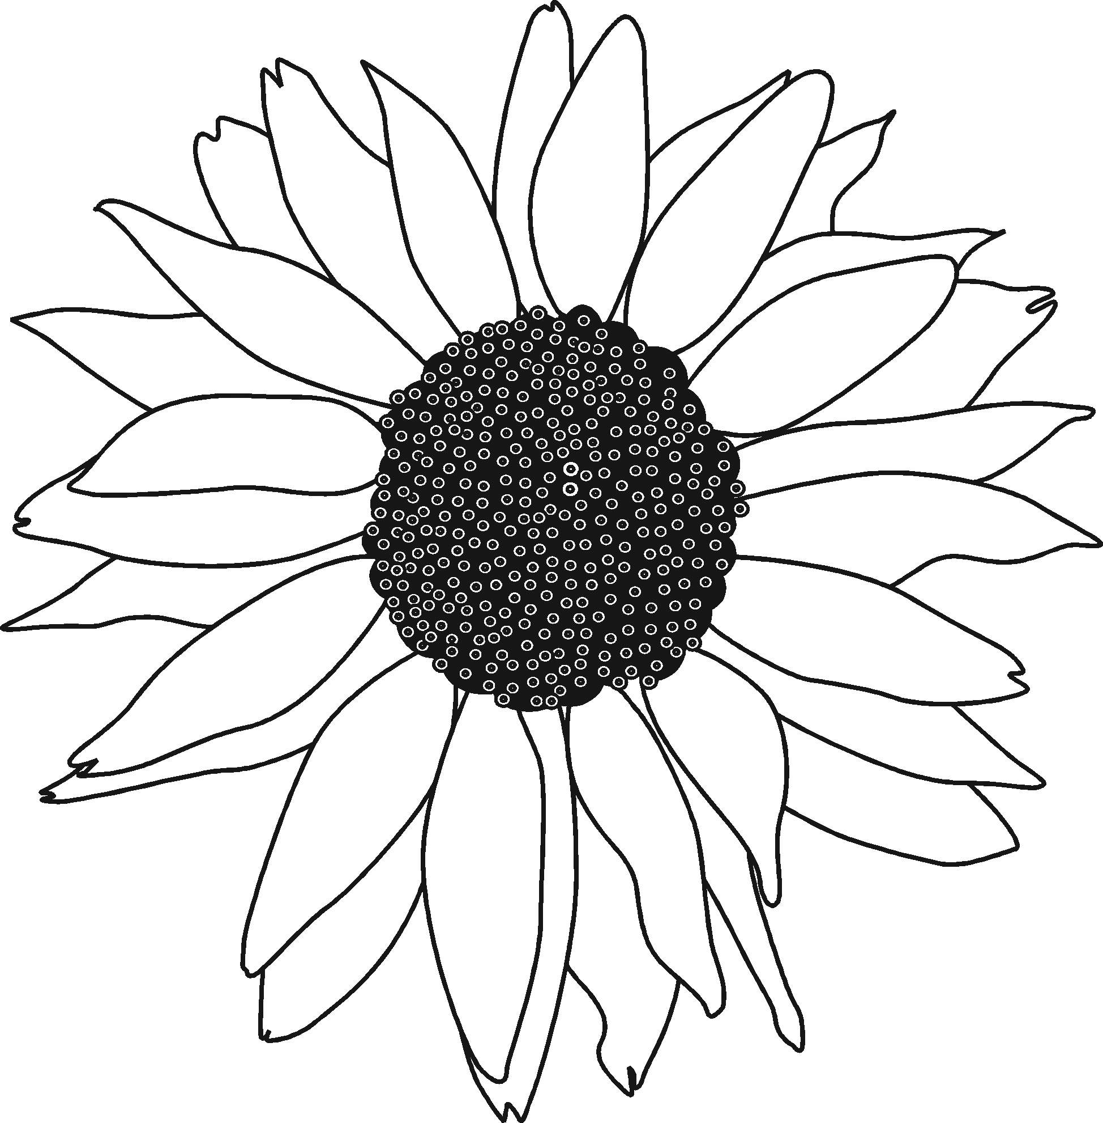
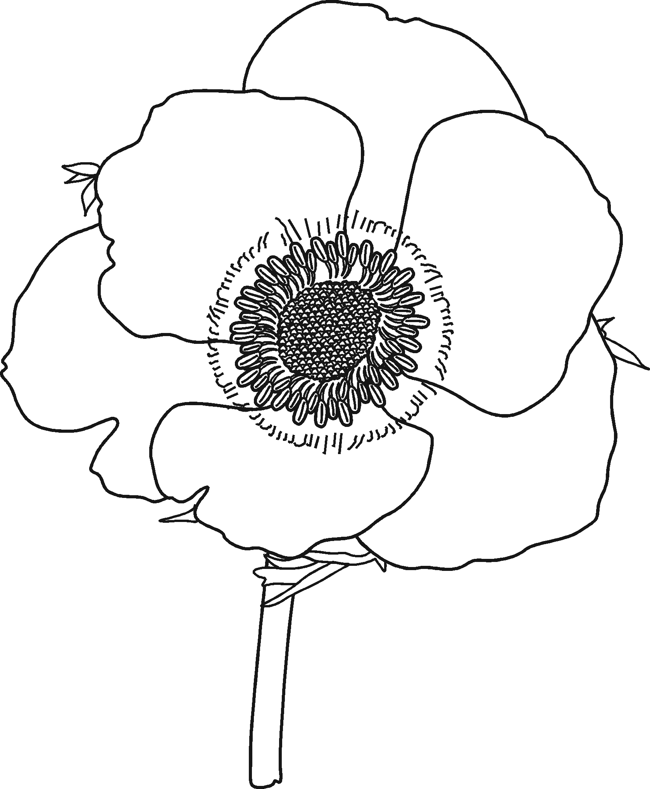

S__ __ F__ __ __ E __ P__ P __ Y L __ T __ __

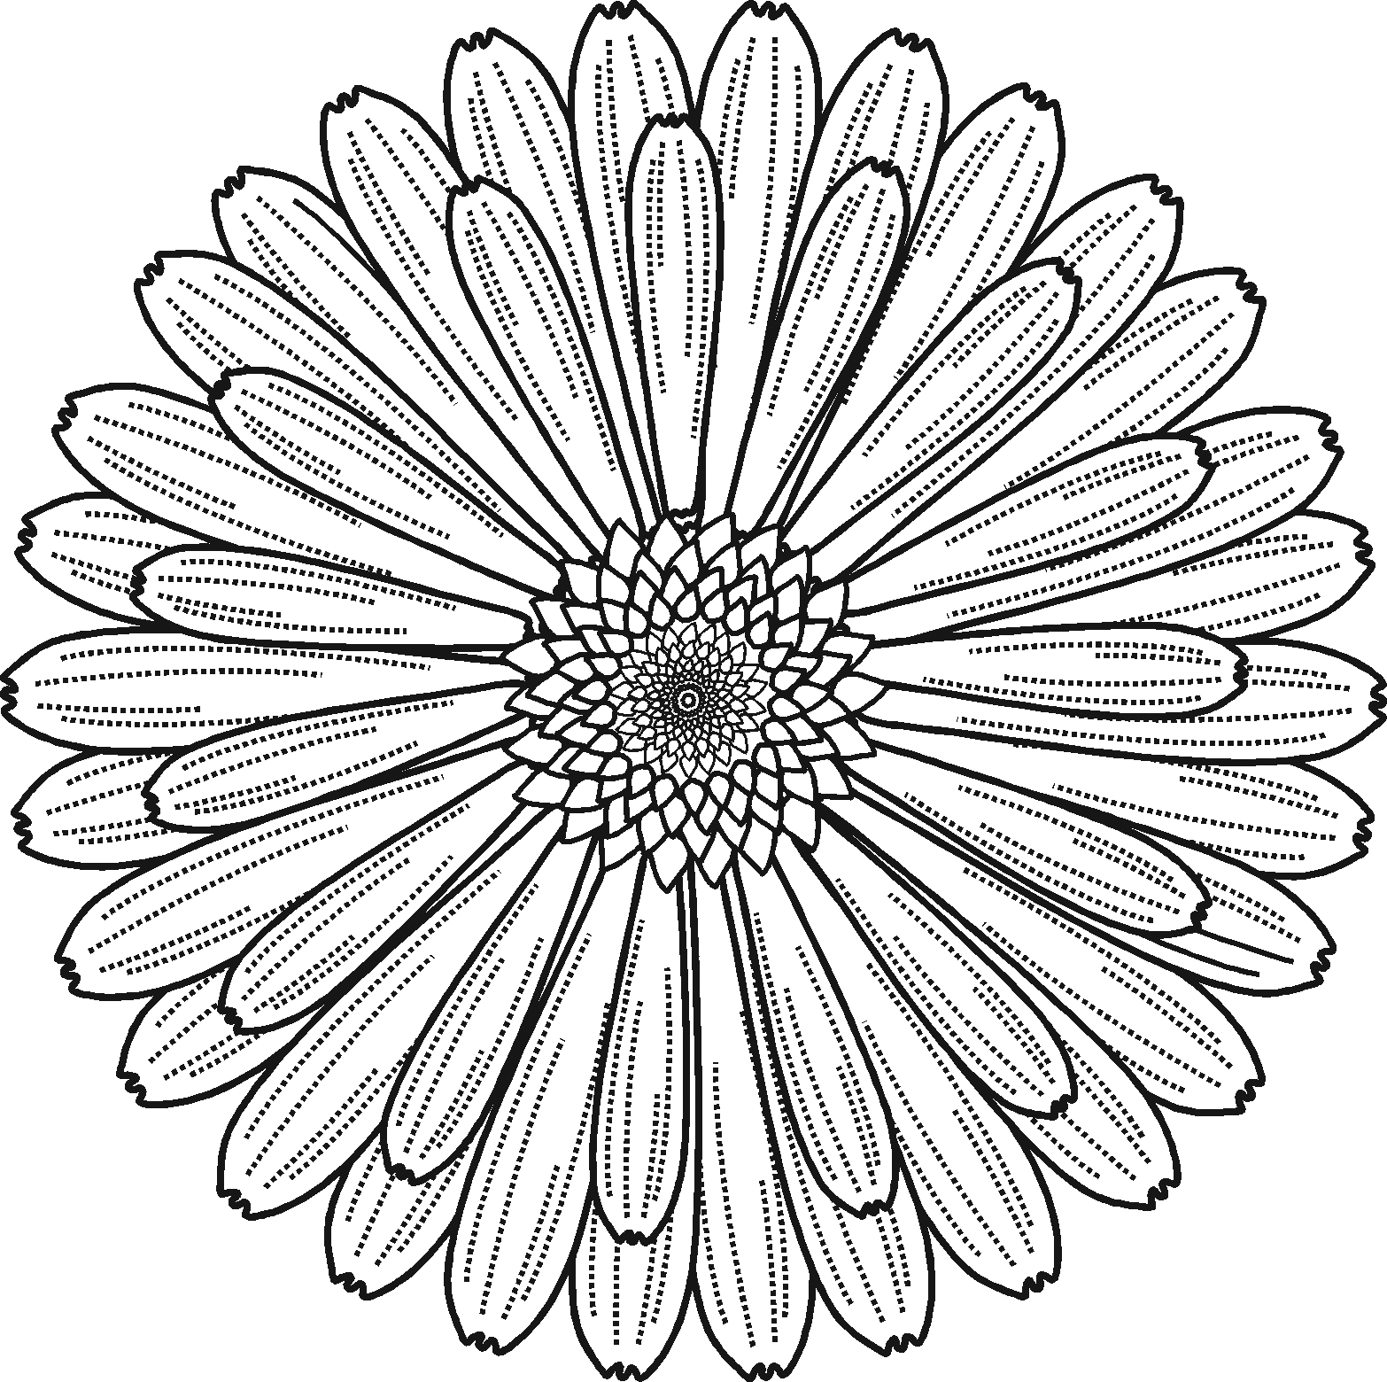
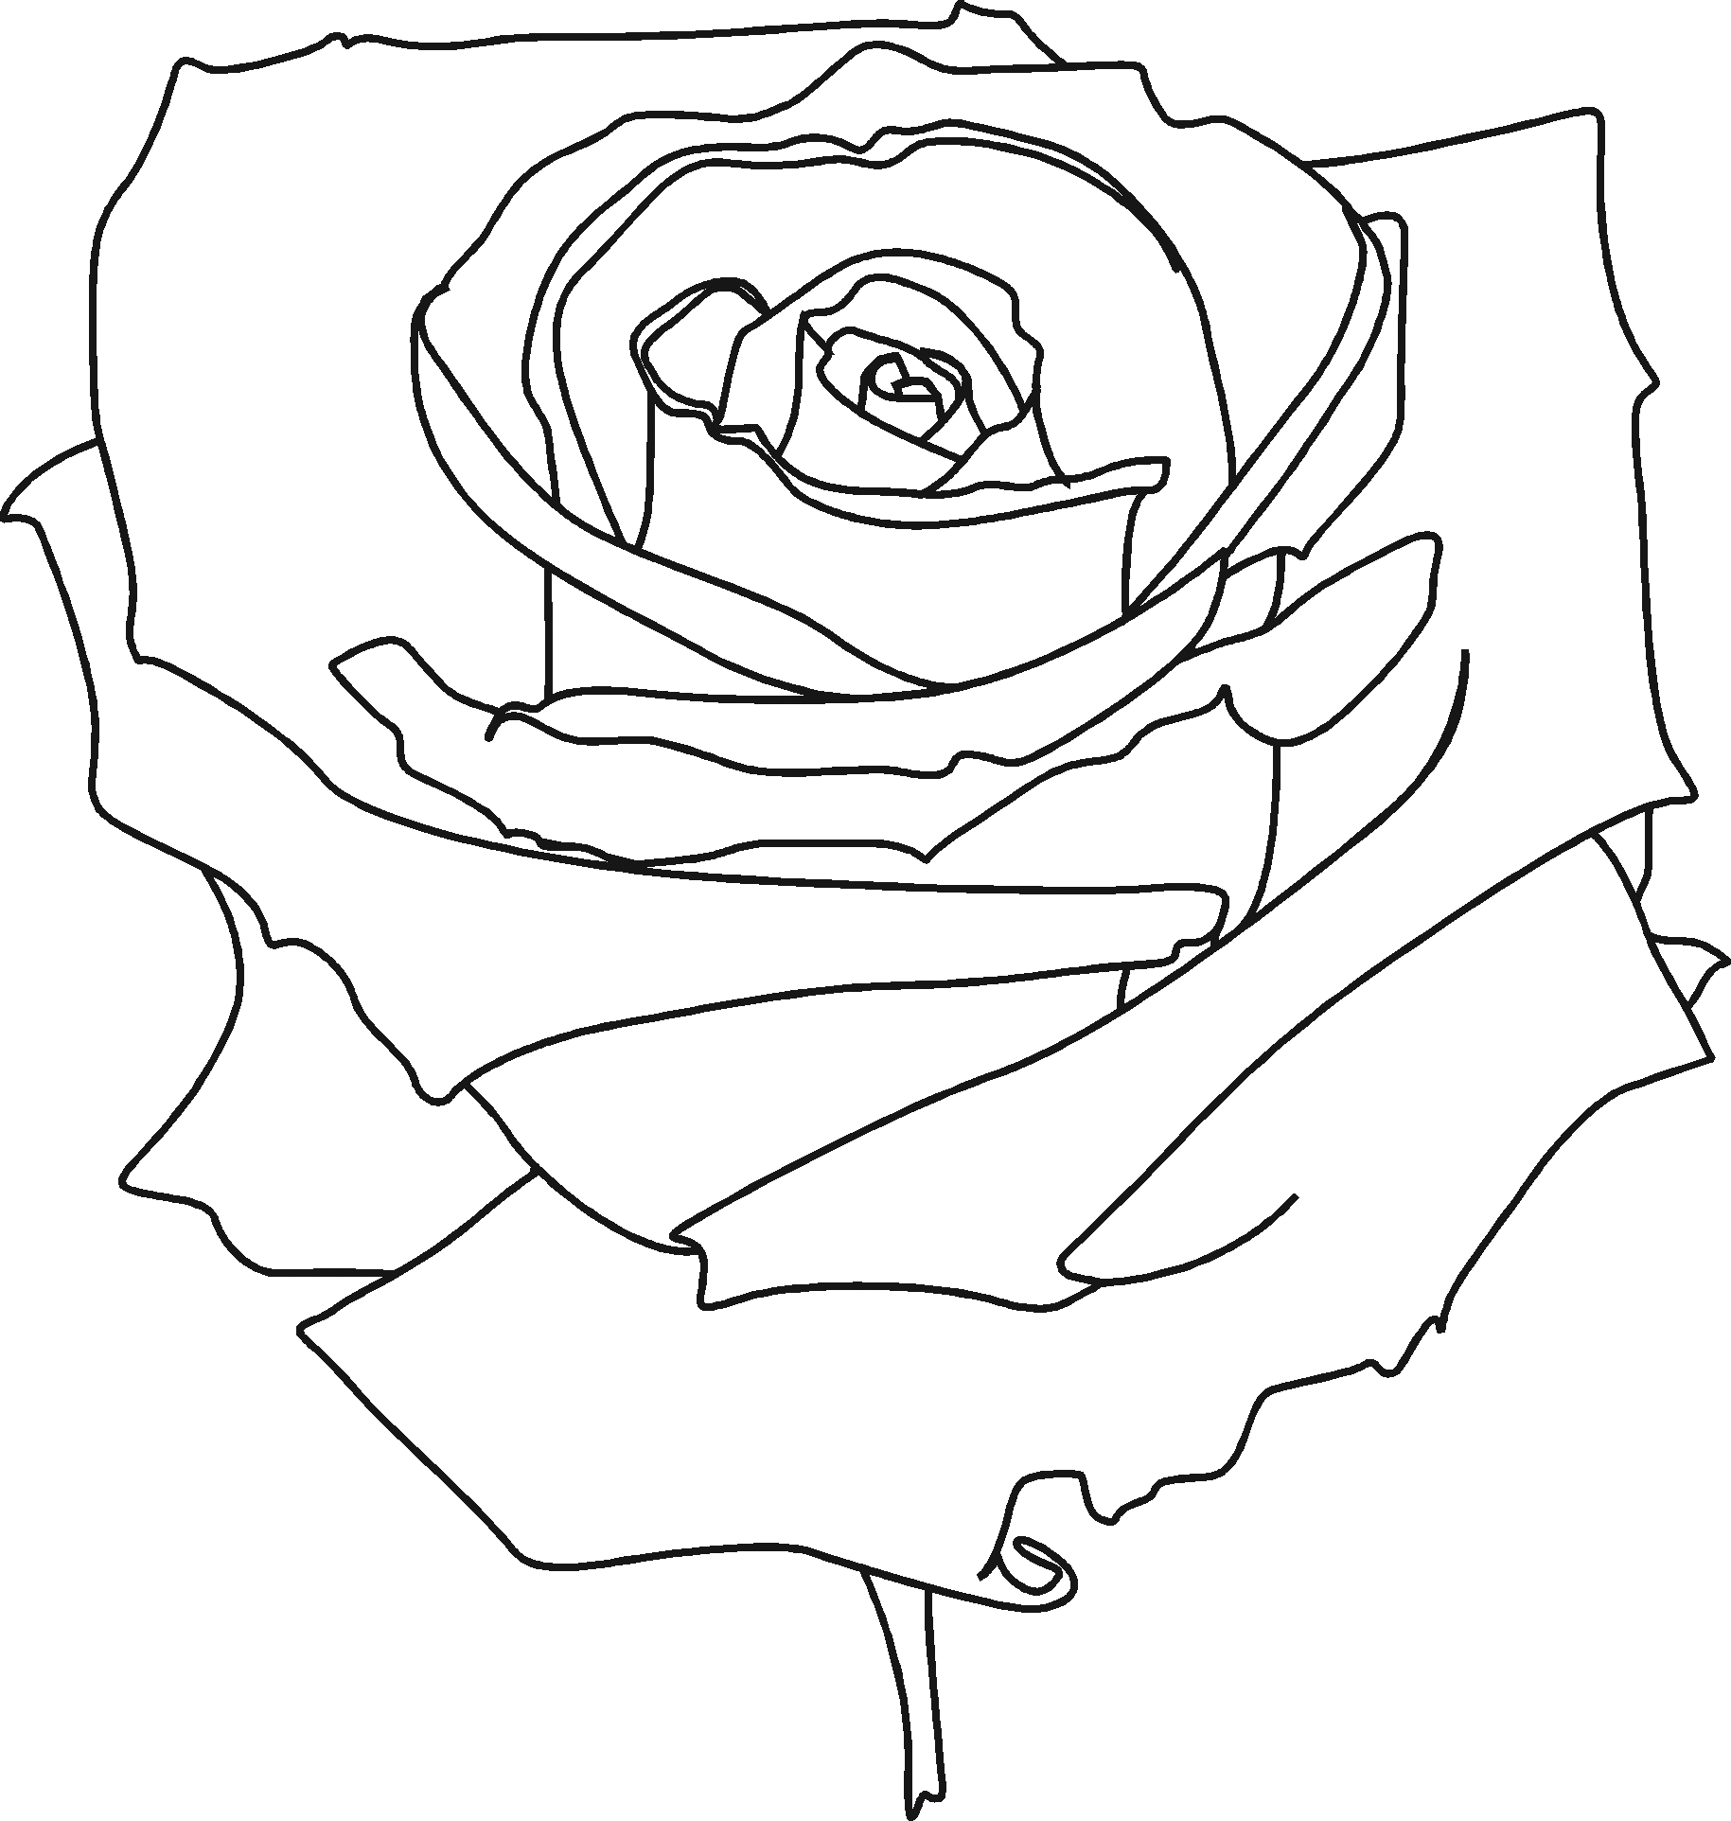

M __ R __ __ __ __ D R __ __ E

