ELEMENTARY
Writing Practice 1

A. Write three sentences about your favourite toy.
_______________________________________________________ _______________________________________________________
_______________________________________________________
_______________________________________________________
_______________________________________________________
B. Look at these pictures. Write about them. You can take help from the clues given in the boxes.
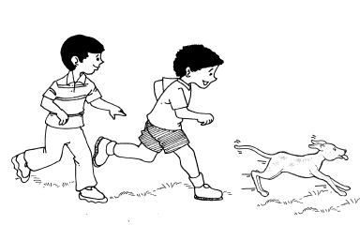

running behind

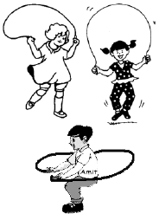

skipping children

_________________________________________________________
_________________________________________________________
_________________________________________________________
_________________________________________________________
_________________________________________________________
_________________________________________________________
_________________________________________________________
________________________________________________________
_________________________________________________________
_________________________________________________________
_________________________________________________________
_________________________________________________________
_________________________________________________________
_________________________________________________________
_________________________________________________________
_________________________________________________________
_________________________________________________________
_________________________________________________________
_________________________________________________________
_________________________________________________________
_________________________________________________________
_________________________________________________________
_________________________________________________________
_________________________________________________________
_________________________________________________________
_________________________________________________________

